War Map of Duchy of Lord Cornelius

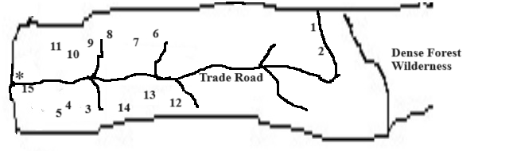

 | LEGEND
1 | Weaton Rye |  | 6 | Meadowbrook |  | 11 | Granite Tor
2 | Aspen Grove |  | 7 | Trout Hollow |  | 12 | Dustin's Ridge
3 | Pine Woods |  | 8 | Ivy Rocks |  | 13 | Golden Fields
4 | Berryfields |  | 9 | Grey Morn |  | 14 | Little Mayfield
5 | Apple Hills |  | 10 | Vine Hills |  | 15 | Green Meadows
 |  |  |  |  |  | * | Treehorn

